**Ordering Scholars Train Passes**

**(Should be available to order from 1st August)**

1. Click on this link [www.wmr.uk/students](http://www.wmr.uk/students) or copy it into your browser.
2. On the page, that appears click on Buy Tickets.

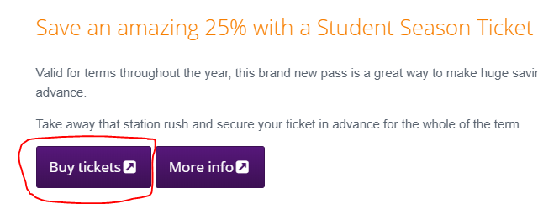

1. On the next page that appears select 24 per page

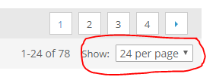

1. Then scroll down the page to the bottom where you will see Hagley Full Term or Hagley Short Term Season Ticket

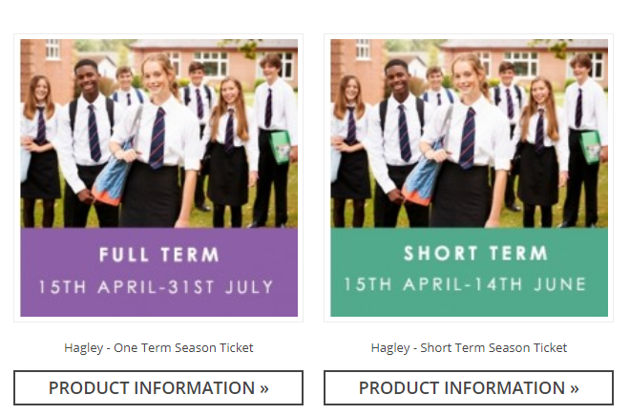

1. Select the pass you wish to order and click on the picture.
2. Scroll down the page to where it says Choose Ticket.

In Status Select age of student

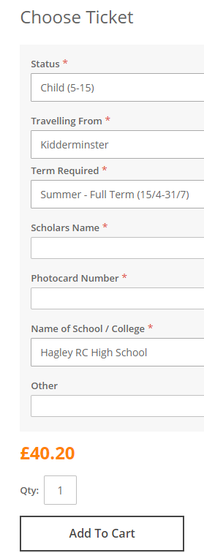

Insert the students first name and last name

Once complete click on Add to Cart

Other can be left blank

Select Hagley RC High School

Insert the photocard number or ‘***New’

Select, which pass you would like

Select the station they travel from

1. Then click on Proceed to Checkout
2. The first time you order a pass you will need to Create an Account so click on Register
3. Complete the information that you are asked for.
4. Select the postal option you would like to use
5. Insert the payment details
6. Review your order and submit it
7. Your pass will be sent to the address you put into Billing Information